|  |
| --- |
| User Manual  Order to cash process(Configuration) |
| REFERENCE: GW/ERP/USER MANUAL |
|  |
| **Genweb2 Ltd.** |
|  |



|  |
| --- |
|  |

# Document Information

|  |  |
| --- | --- |
| Document Name | User manual (Configuration)Order to cash process |
| Document Author | Rashedul Alam |
| Document Version | 1.0 |
| Release Date | 12th Dec, 2018 |

|  |  |
| --- | --- |
| Review by | Md. Mahfuzur Rahman |
| Review Date | 30th June, 2020 |
| Approved By |  |
| Approval Date |  |

# Document History

|  |  |  |  |  |  |
| --- | --- | --- | --- | --- | --- |
| A=Added, M=Modified, D=Delete | | | | | |
| **Version No** | **Date** | **Section No** | **A/M/D** | **Description of Change** | **Author** |
| 1.0 | 12-Dec-2018 |  | A | Initial | Rashedul Alam |
| 1.2 | 28-June-2020 |  | A | Product category,Sales order type, Payment terms modification & Some latest image input | Rashedul Alam |

Contents

A. Document Information 2

B. Document History 2

1. Introduction 4

1.1 Purpose of User manual 4

2. Configuration 4

2.1 Creation of product category by Product Manager 4

2.2 Creation of packing modes by Product Manager 6

2.3 Create Attributes by Product Manager 7

2.4 Create Attribute values configure by Product Manager 8

2.5 Create Unit of Measure (UoM) categories by Product Manager 9

2.6 Create Unit of Measure (UoM) by Product Manager 10

2.7 Create contract tags by Product manager 11

2.8 Create contact title by Product Manager 12

2.9 Create Currencies by HR Manager 13

2.10 Create Sales team by Head of Sales 14

2.11 Create Sales Order Types by Head of Sales 15

2.12 Create Sales Channel by Head of Sales 16

2.13 Payment terms Setup by Head of Sales 18

# 

# 1. **Introduction**

The User Manual contains all essential information for the user to make full use of the information system. This manual includes a description of the system functions and capabilities, contingencies and alternate modes of operation, and step-by-step procedures for system access and use.

## Purpose of User manual

The purpose of this User Manual is to clearly identify the customer requirements and provide a detailed document. The customer will read this document and get a clear view of the sales module.

This document is the User Manual of the Order to cash process. It is intended to provide all the necessary information to use this software to develop application software running on the workstation.

# 2. Configuration

Some configuration require for Sales module, multiple user can configure this.

## 2.1 Creation of product category by Product Manager

Product category requires for Product creation, several types of product category are; All, Saleable etc.

We can create Product category using the menu **sales ‣ Configuration ‣ Product category** and click **Create.**

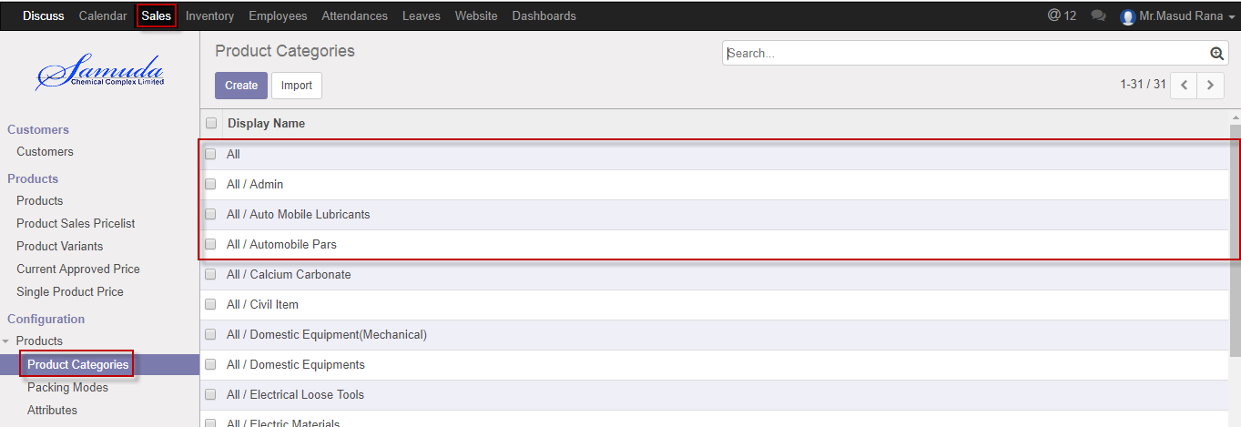

Figure: Product category List view

We need to set the following:-

**Category name**: A Category type name.

**Parent category:** Select parent category.

**Closing method:** Select closing method.

**Inventory Valuation:** Select inventory valuation.

After entering all information click **Save**.

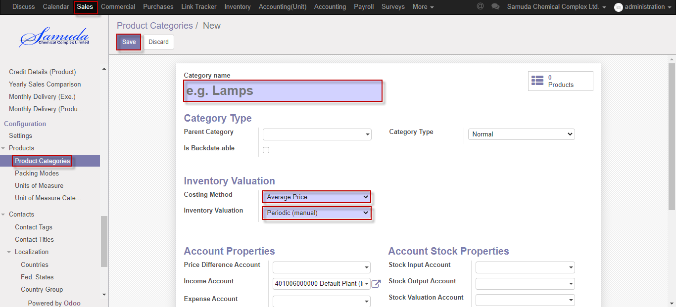

Figure: Create a product category

## 2.2 Creation of packing modes by Product Manager

Packing modes requires for SO creation, several types of packing modes are; Bulk, 250kg with drum, 900kg jar etc.

We can create Packing modes using the menu **sales ‣ Configuration ‣ Packing modes** and click **Create.**

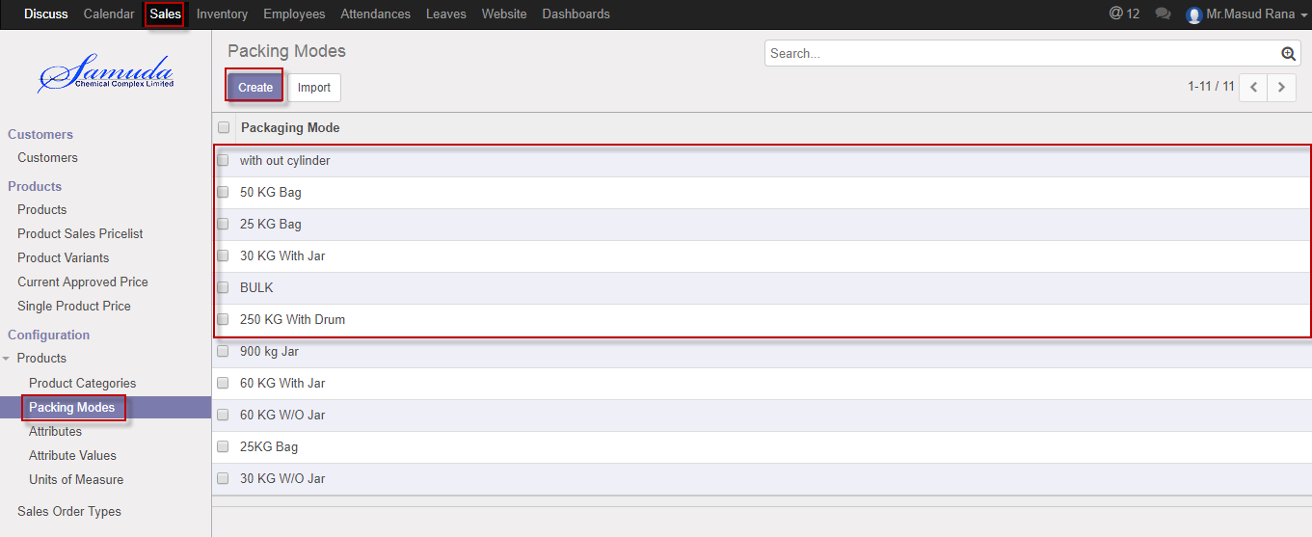

Figure: Packing modes List view

We need to set the following:-

**Packing mode**: Enter A Packing mode name.

**UoM:** Select UoM.

**Sequence:** Enter Sequence.

After entering all information click **Save**.

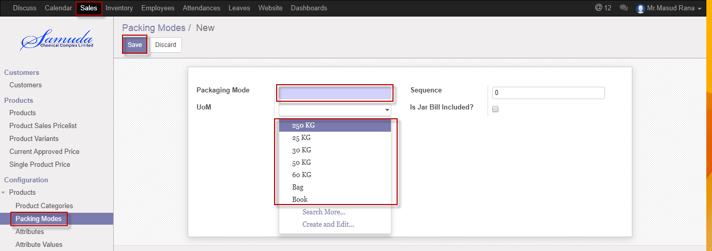

Figure: Create a packing mode

## 2.3 Create Attributes by Product Manager

Attributes can create by product Manager, Attribute is needed for Attribute value set. It is needed for product value creation.

We can create attribute using the menu **Sales ‣ Configuration ‣ Attribute** and click **Create.**

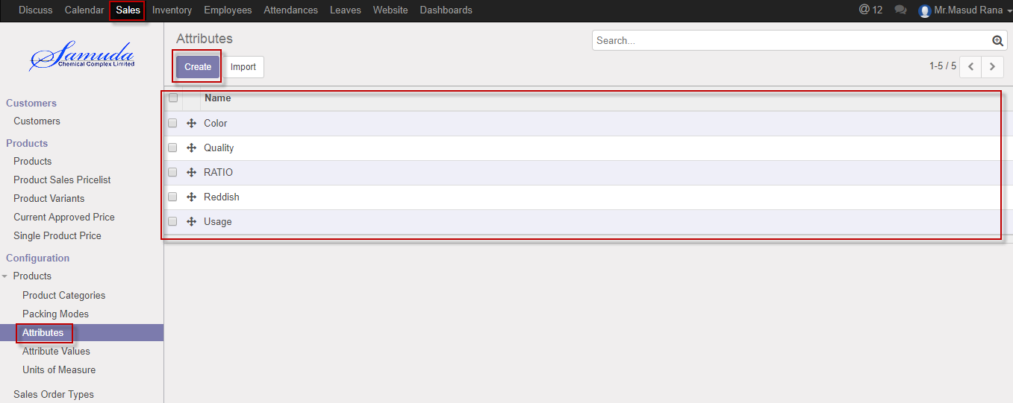

Figure: Attributes List view

We need to set the following:-

**Name:** Enter attribute name.

**Check:** Select checkbox.

After entering all information click **Save**.

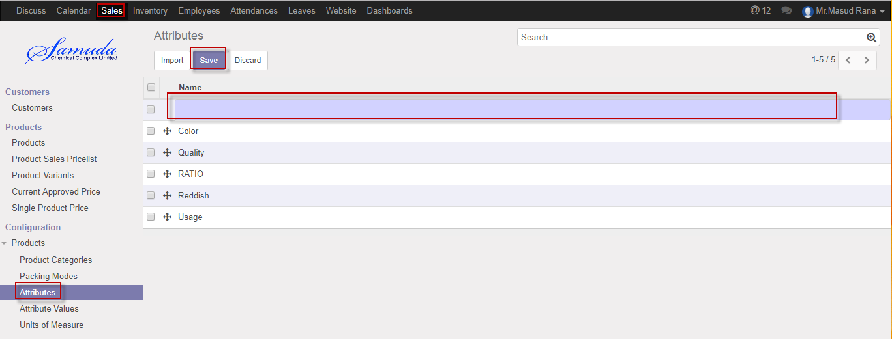

Figure: Create an attributes

## 2.4 Create Attribute values configure by Product Manager

Attribute values can be set by Product manager, attribute values will be needed when we define products different variations.

**Sales ‣ Configuration ‣ Attribute values** and click **Create.**

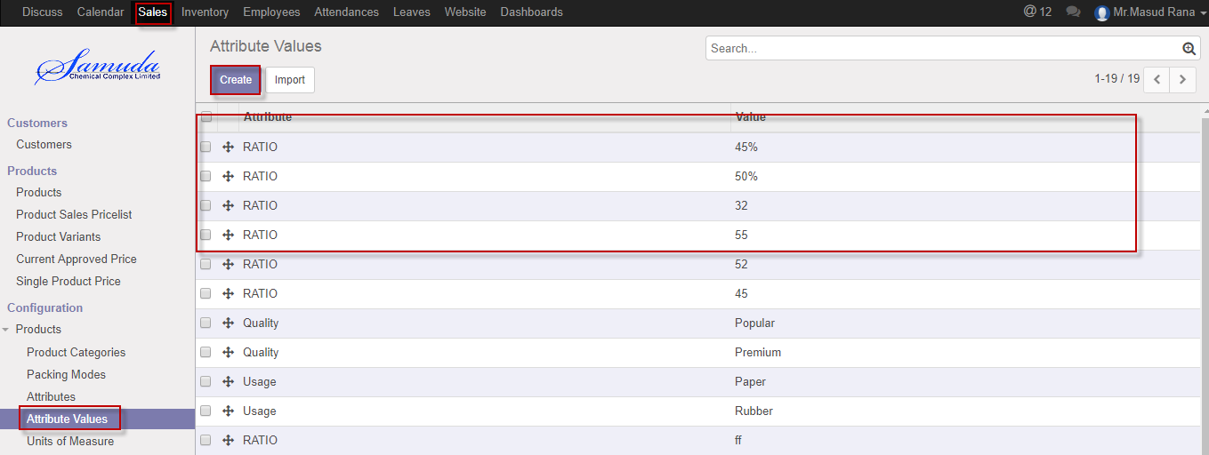

Figure: Attribute values List view

We need to set the following:-

**Attribute**: Select attribute.

**Value:** Enter a value.

After entering all information click **Save**.

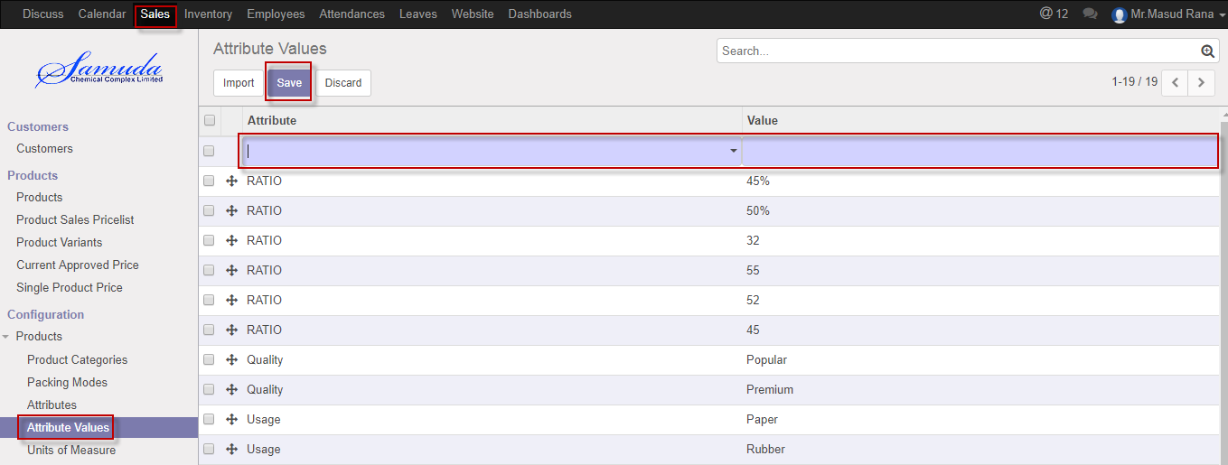

Figure: Create an Attribute values

## 2.5 Create Unit of Measure (UoM) categories by Product Manager

Unit of Measure categories require for Unit of measure entry & it will set by Product manager.

We can create Unit of Measure (UoM) categories using the menu **sales ‣ Configuration ‣ Unit of measure categories** and click **Create.**

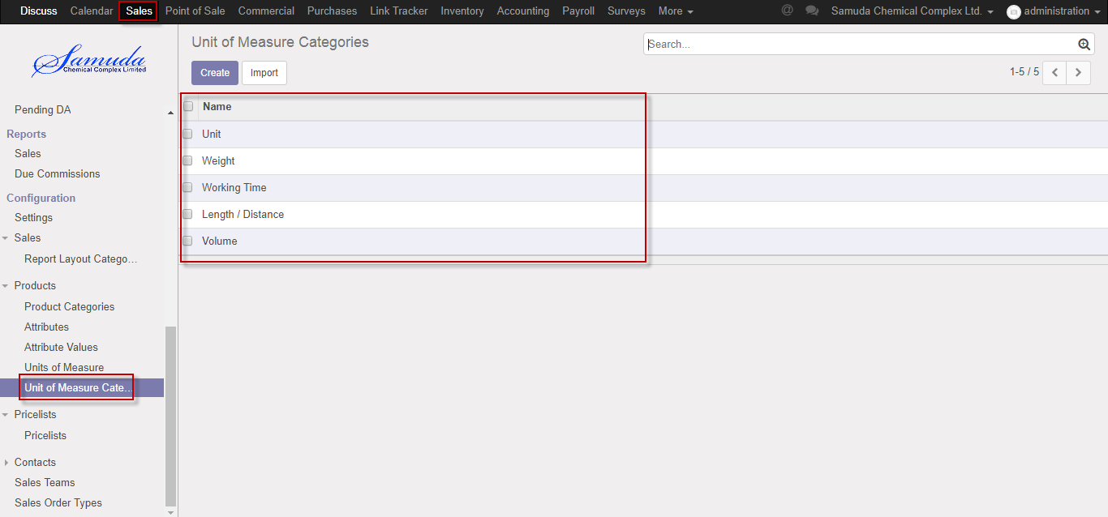

Figure: Unit of measure categories list view

We need to set the following:-

**Name**: Enter a name

After entering all information click **Save**.

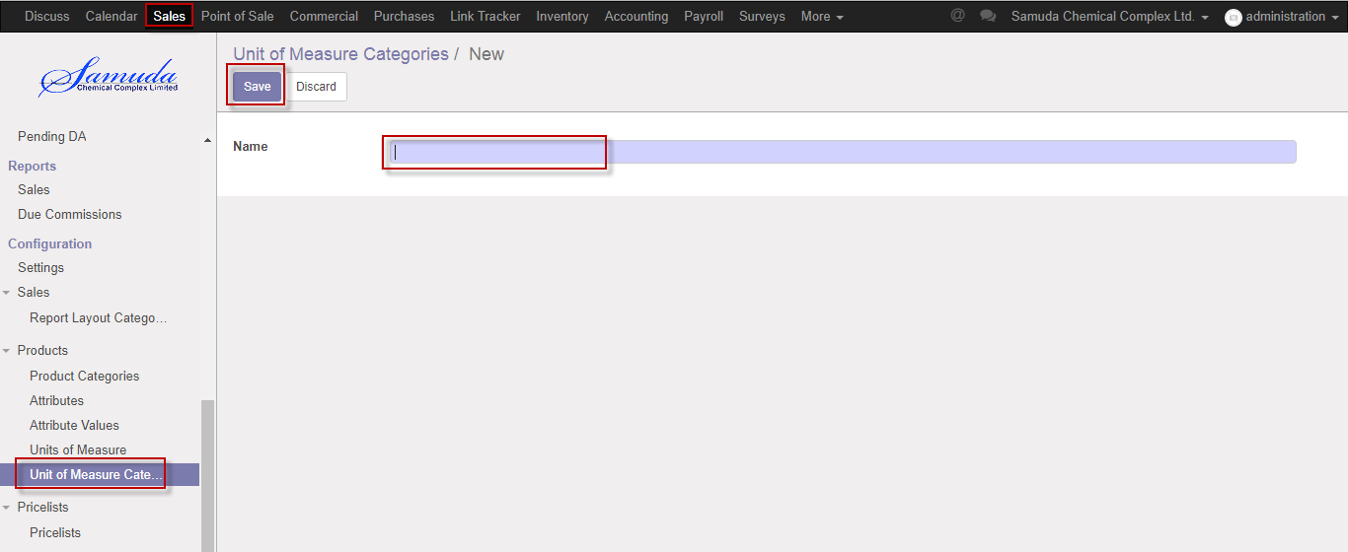

Figure: Create Unit of Measure (UoM) categories.

## 2.6 Create Unit of Measure (UoM) by Product Manager

Unit of measure require for Sales order entry & it will set by Product manager.

We can create Unit of measure using the menu **Sales ‣ Configuration ‣ Unit of measure** and click **Create.**

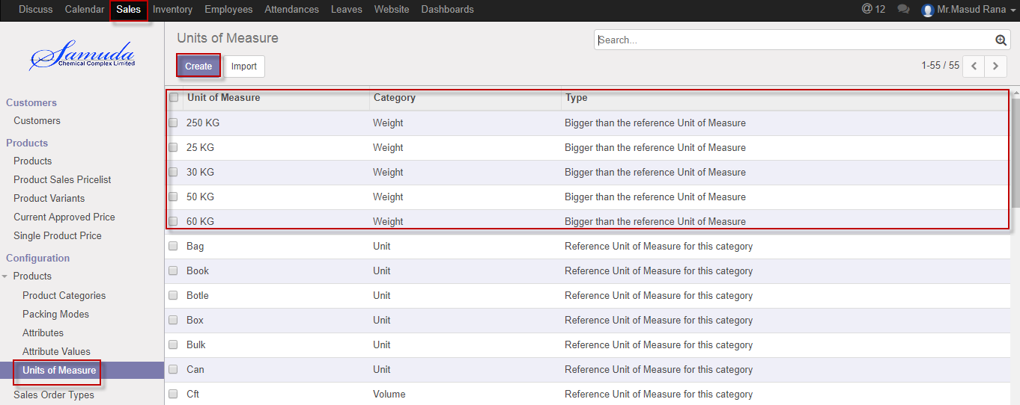

Figure: Unit of measure List view

We need to set the following:-

**Unit of measure**: Enter Unit of measure.

**Category:** Select category.

**Type:** Select a type.

**Rounding precision:** Enter rounder precision time

**Active:** Check active

After entering all information click **Save**.

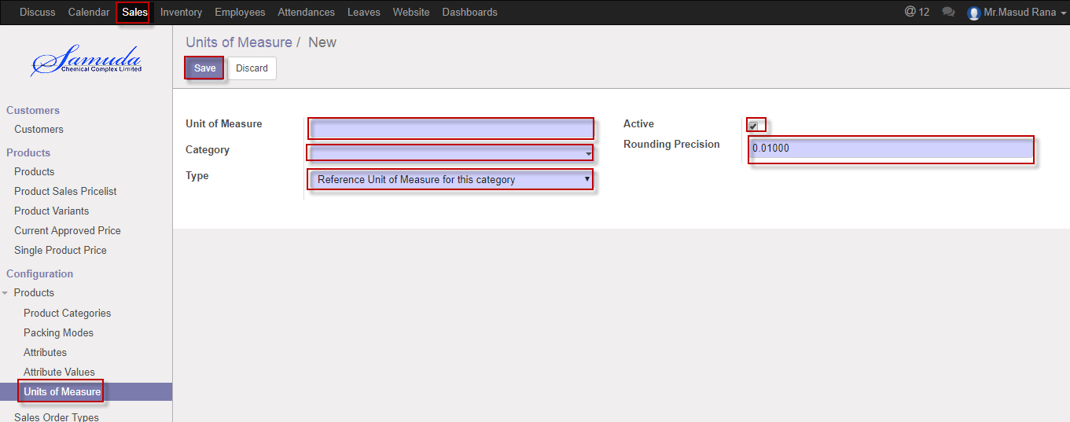

Figure: Create a Unit of measure

## 2.7 Create contract tags by Product manager

Contract tag is need for contract creation .Product manager will set it.

We can create Contract tags using the menu **Sales ‣ Contacts>>Contact tags** and click **Create.**

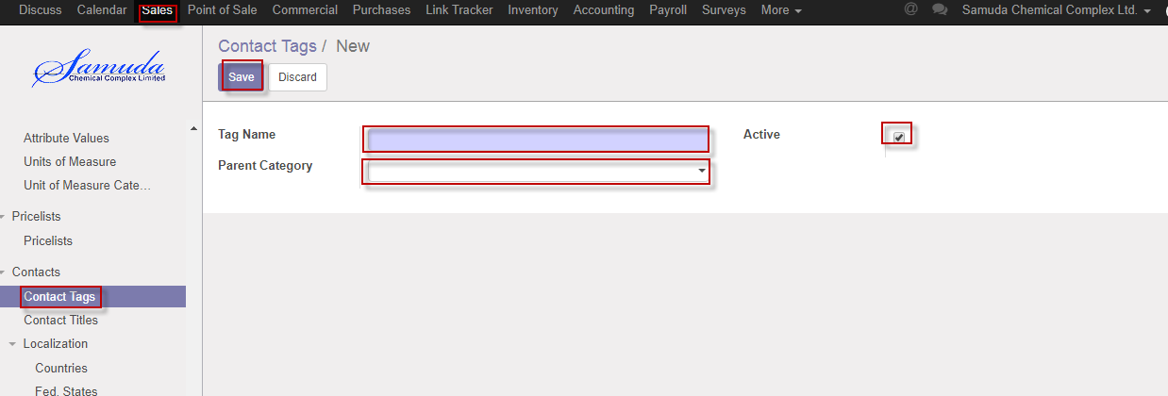

Figure: Create a Contract tags

We need to set the following:-

**Tag name**: Select tag name.

**Parent category:** Select parent category.

**Active:** Check active.

After entering all information click **Save**.

## 2.8 Create contact title by Product Manager

Contract title is need for contract creation .product Manager will be set it. It will be used from customers menu.

We can create Contact title using the menu **Sales ‣ Contact>>Contact title** and click **Create.**

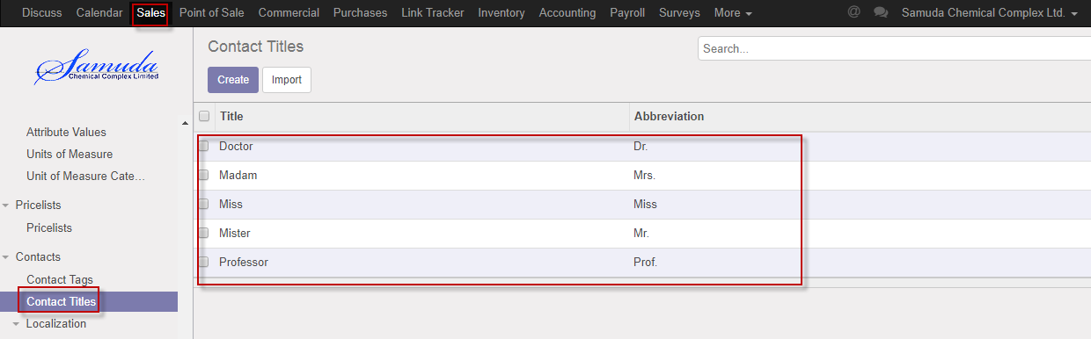

Figure: Contact title List view

We need to set the following:-

**Title**: Enter title.

**Abbreviation:** Enter abbreviation.

After entering all information click **Save**.

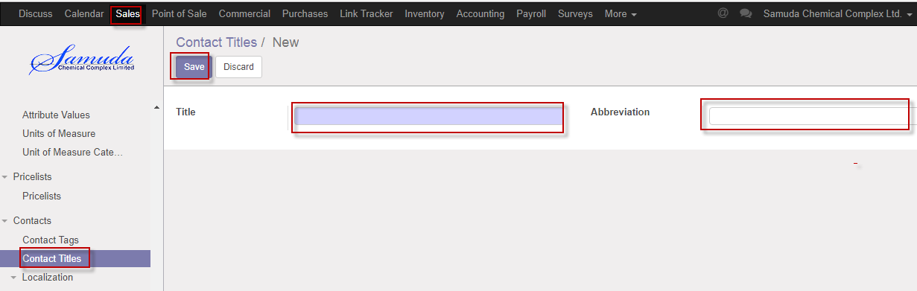

Figure: Create a contact title

## 2.9 Create Currencies by HR Manager

HR manager will set currencies.

We can create currencies using the menu **Sales ‣ Localization>>currencies** and click **Create.**

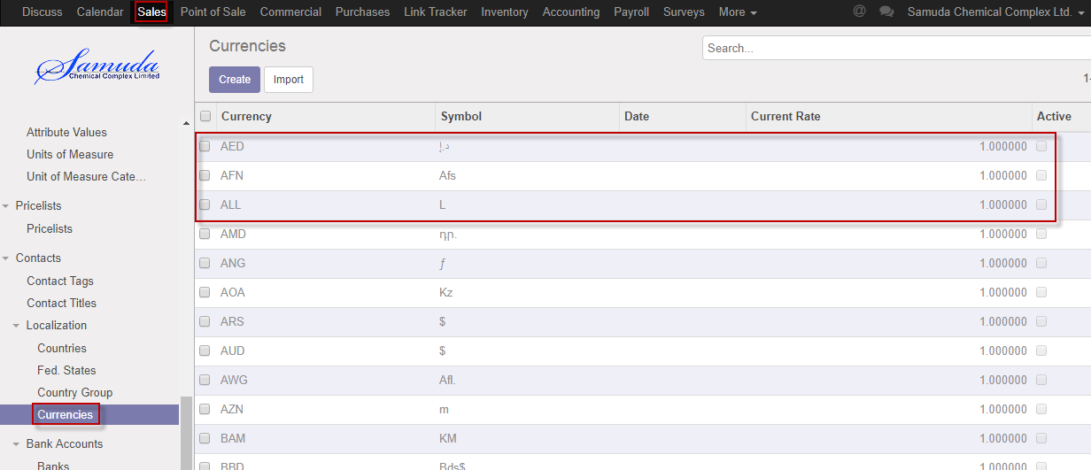

Figure: Currencies List view

We need to set the following:-

**Currency**: Enter currency.

**Rounding factor:** Enter rounding factor.

**Symbol:** Enter symbol.

After entering all information click **Save**.

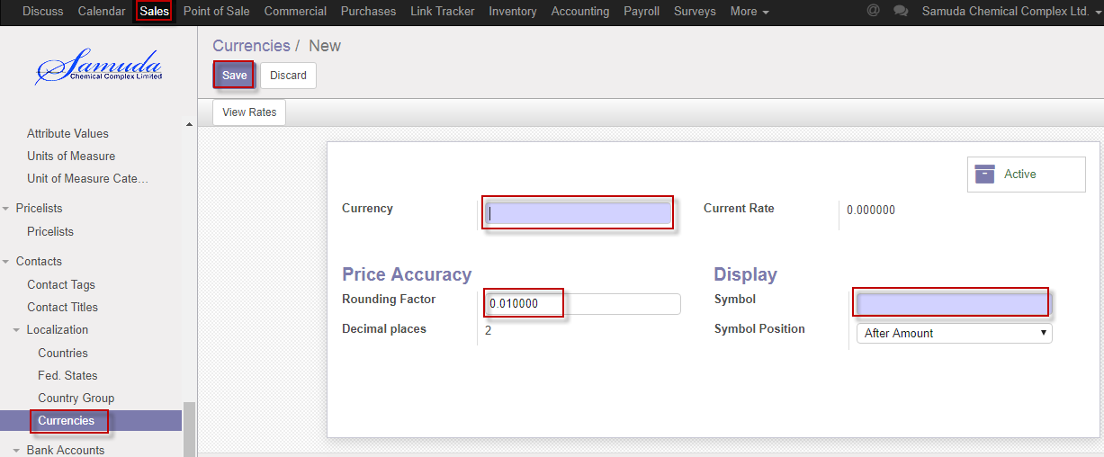

Figure: Create currencies

## 2.10 Create Sales team by Head of Sales

Head of Sales will set Sales team.

We can create Sales Team using the menu **Sales ‣ Configuration>>Sales Teams** and click **Create.**

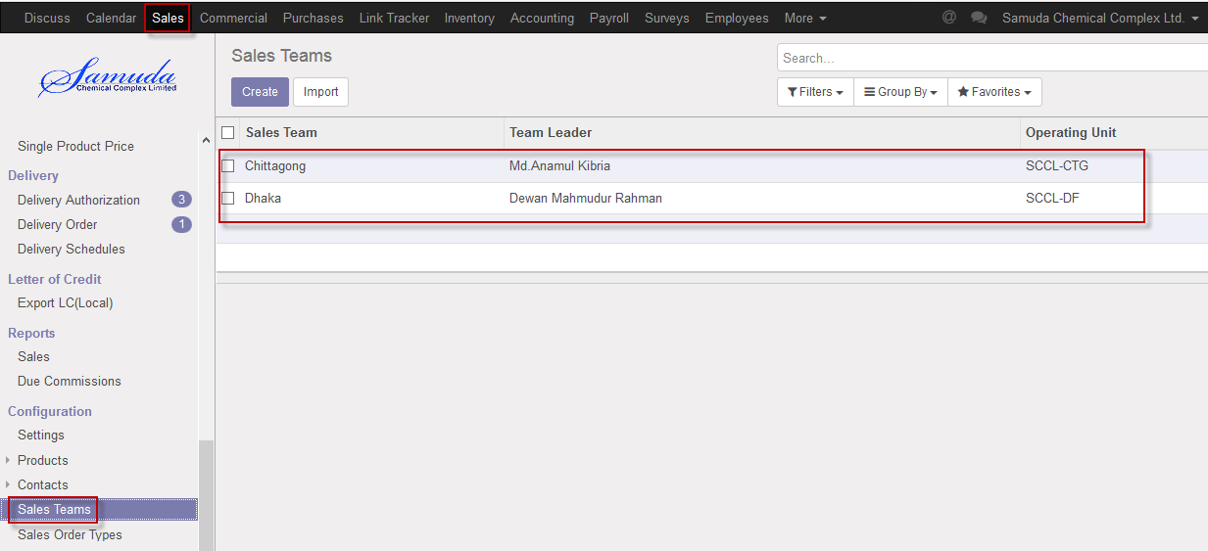

Figure: Sales Teams List view

We need to set the following:-

**Sales team**: Enter Sales team.

**Team lead:** Select team lead.

**Team member:** Add team member.

After entering all information click **Save**.

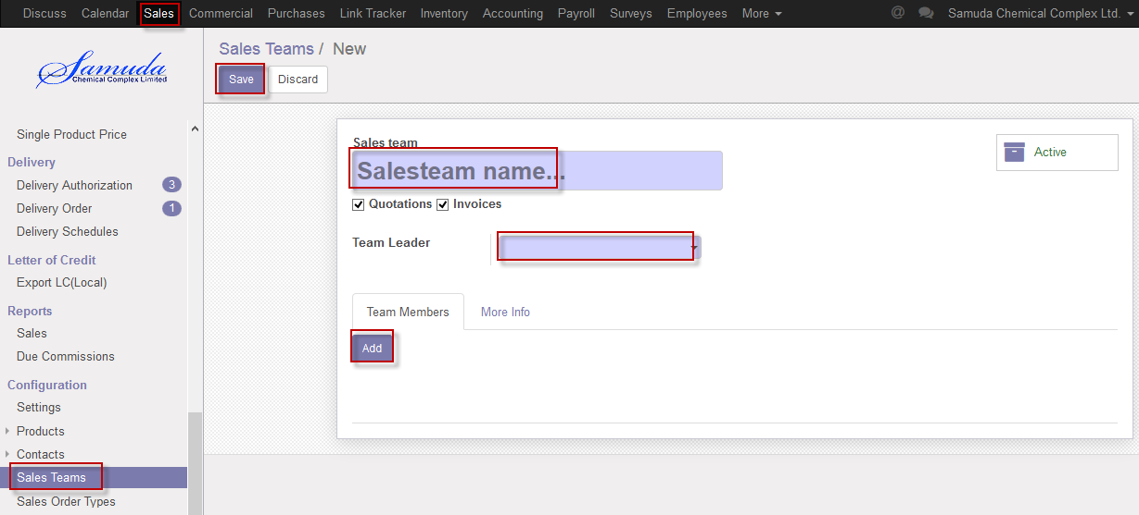

Figure: Create Sales Teams

## 2.11 Create Sales Order Types by Head of Sales

Head of Sales will set Sales order types.

We can create Sales Order Types using the menu **Sales ‣ Configuration>>Sales Order Types** and click **Create.**

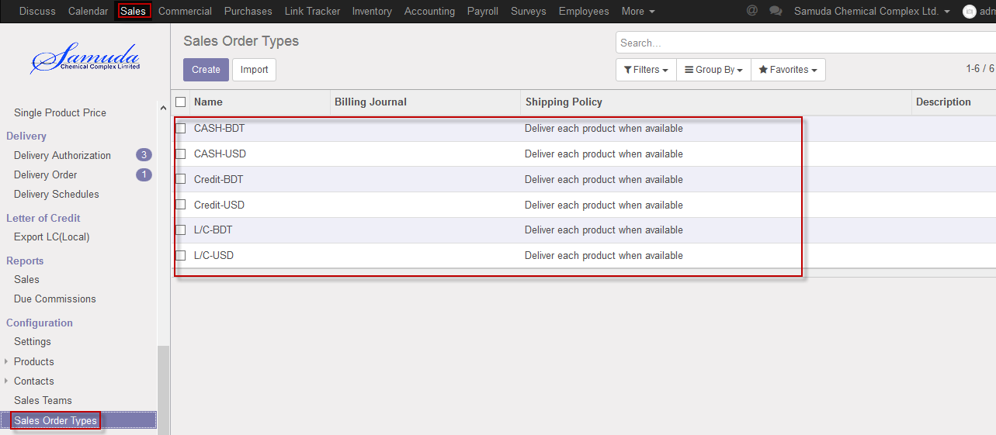

Figure: Sales Order Types List view

We need to set the following:-

**Name**: Enter Name.

**Sale order type:** Select Sale order type.

**Region type:** Select region type.

**Currency:** Select Currency.

After entering all information click **Save**.

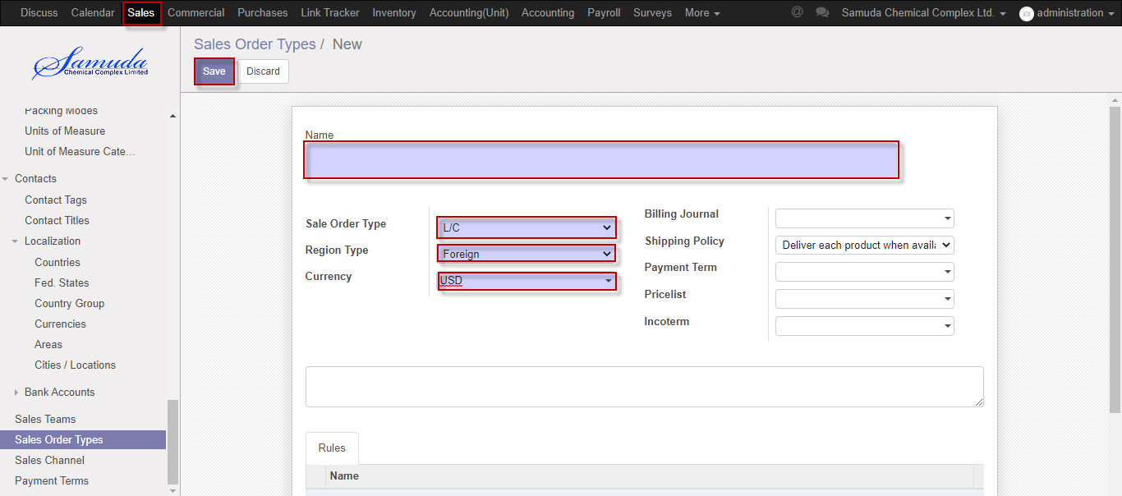

Figure: Create Sales Order Types

## 2.12 Create Sales Channel by Head of Sales

Head of Sales will set Sales Channel.

We can create Sales Channel using the menu **Sales ‣ Configuration>>Sales Channel** and click **Create.**

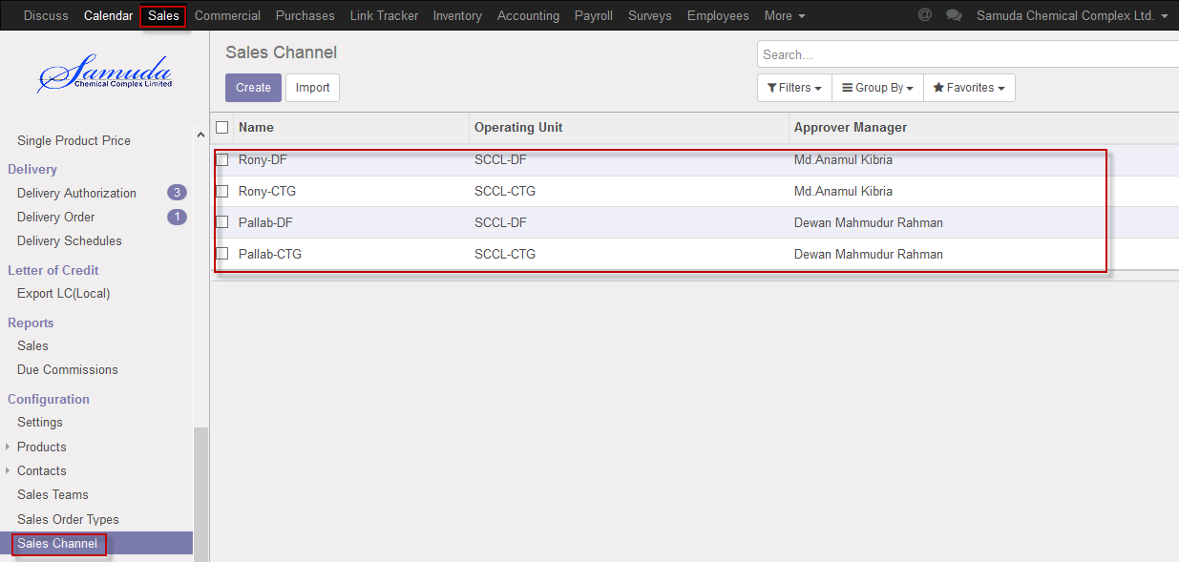

Figure: Sales Channel List view

We need to set the following:-

**Name**: Enter Name.

**Operating Unit:** Select Operating Unit.

**Approver Manager:** Select Approver Manager.

**Warehouse:** Select Warehouse.

After entering all information click **Save**.

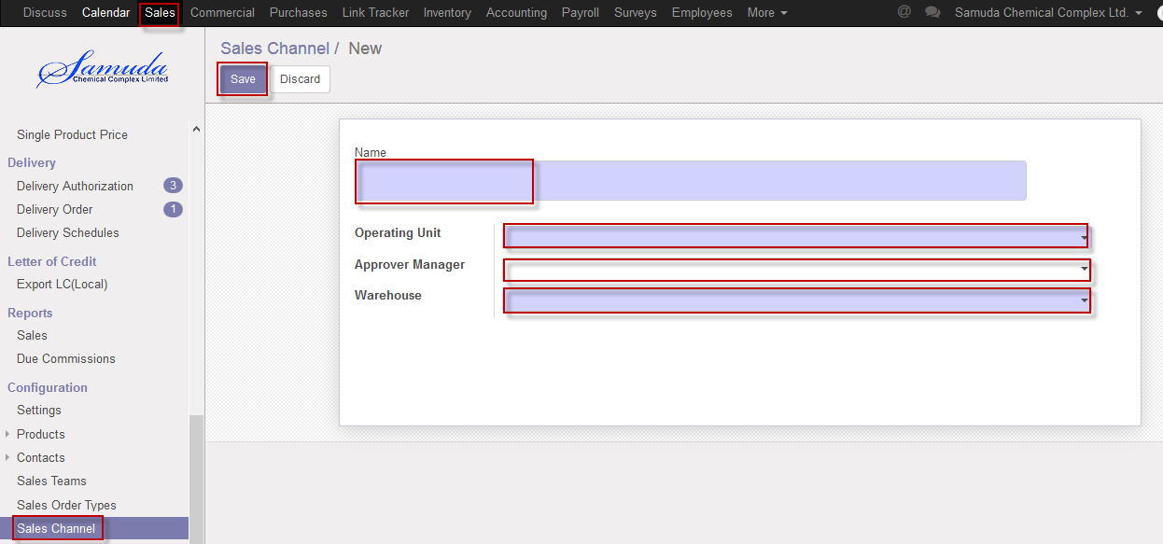

Figure: Create Sales Channel

## 2.13 Payment terms Setup by Head of Sales

Head of Sales will set Payment terms Setup.

We can create Terms Setup using the menu **Sales ‣ Configuration>>Payment terms Setup** and click **Create.**

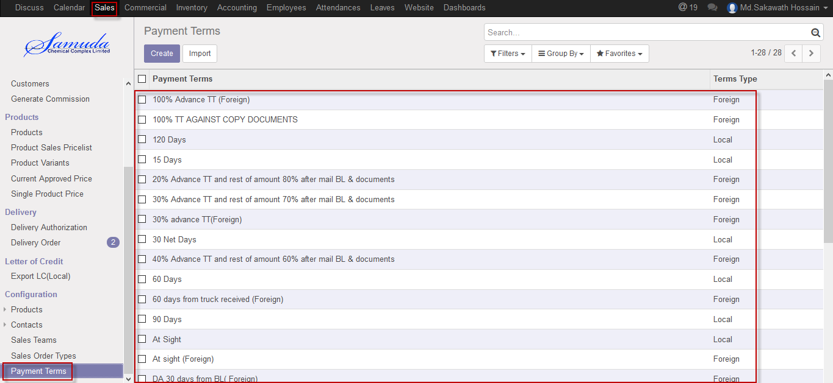

Figure: Payment terms List view

We need to set the following:-

**Payment Terms**: Enter Payment terms.

**Terms type:** Select Terms type from radio button.

**Terms & Conditions:** Enter terms & condition**.**

After entering all information click **Save**.

